* **Steps for installation and crating accounts**

1. Create an account on GitHub by username password with your company mail id

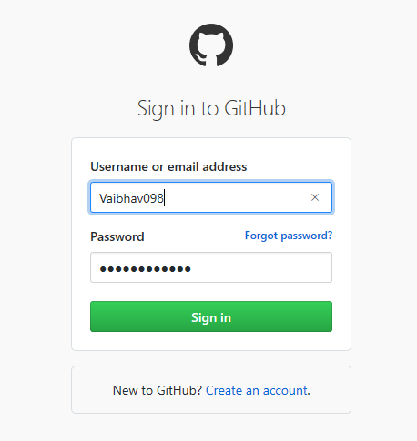

1. Once you done with this open the invitation link sent by email in the browser,now you can you are added for particular projects

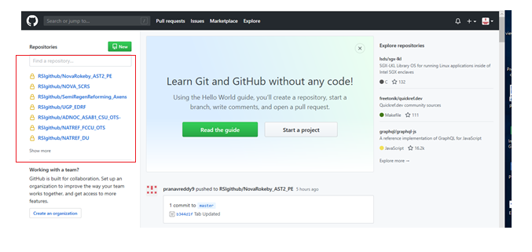

1. Similarly do for source tree installation , this application will help us to for using Github application online

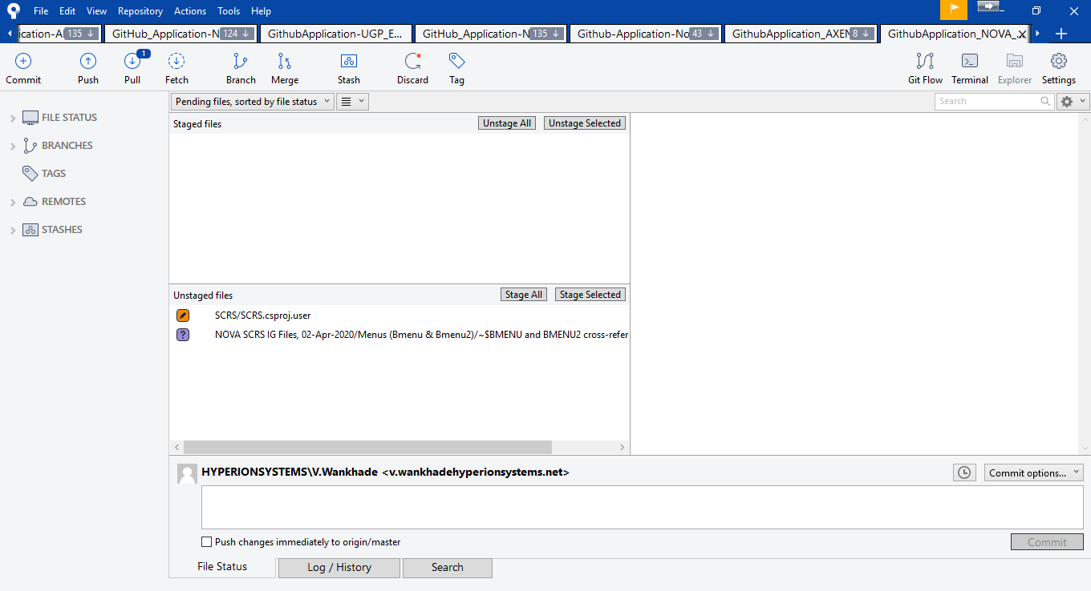

* **Steps for cloning the project repository using SOURCETREE application**

1. Open the invitation link sent by email in the browser.
2. Open the SOURCETREE application and Click “+” button on the upper toolbar to clone the project/repository.

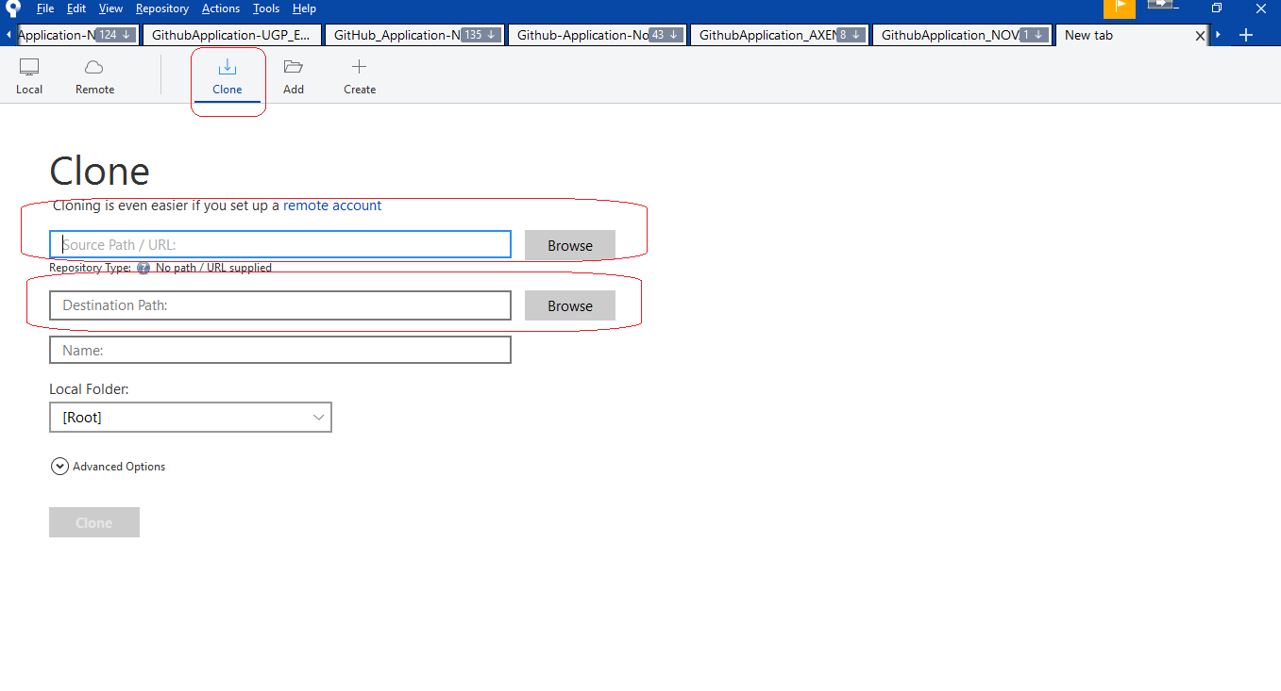

1. Select the Clone option once it is available.
2. Copy the URL address from link and paste in repository address, 1st option

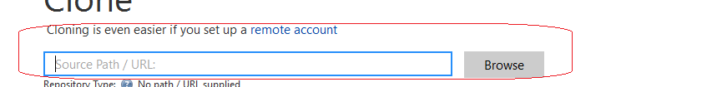

1. Make sure a new folder on the local drive is created for particular GITHUB.
2. Assign the path of this folder



1. Click CLONE option

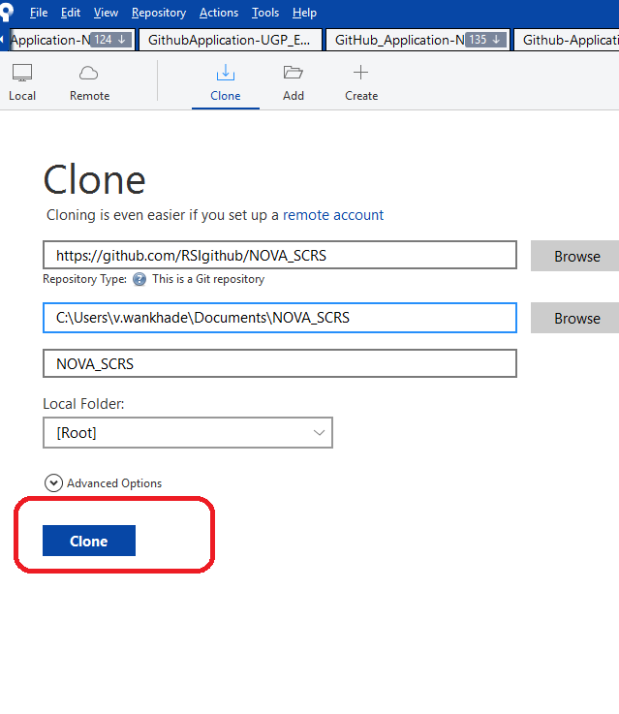

1. Repository cloning will start.
2. Cloning will take some time.
3. Once the cloning is finished all the data on the repository can be accessed in the GITHUB folder on the local drive.
4. We can create different of repository for various different projects.



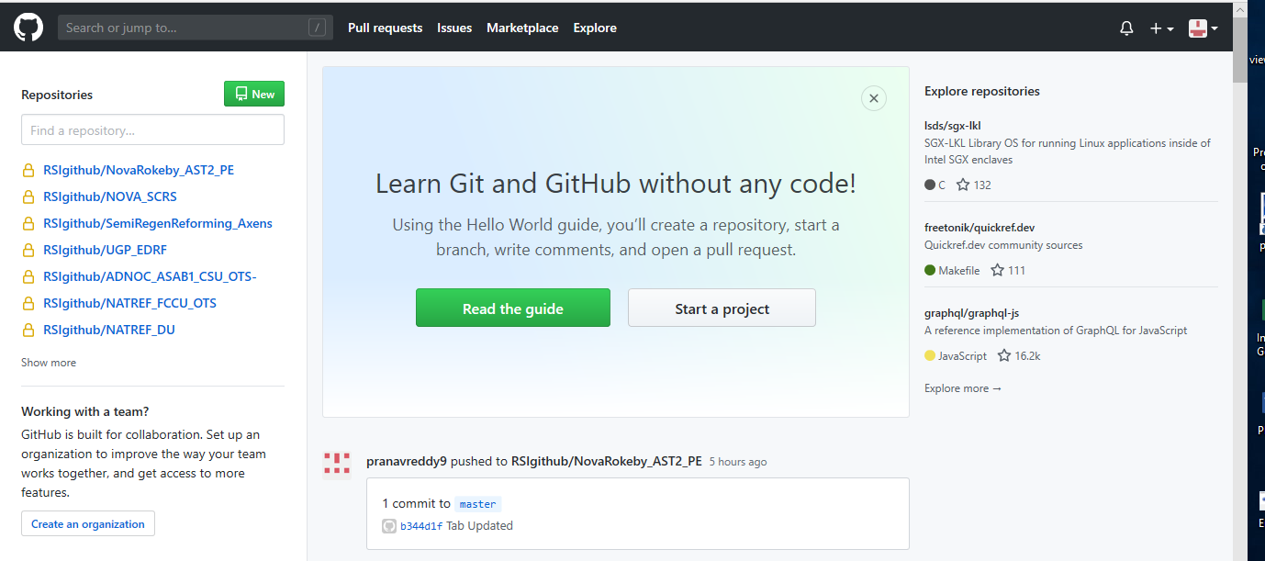

* **How to operate/use Source tree**

1. **On top bar of source tree you can see the options for commit, push, pull, fetch, branch, merge, stash, discard, tag**

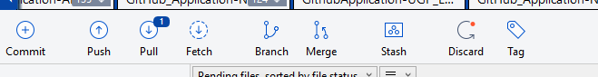

1. **Mostly useful is coomit, push, pull only generally we are not using rest.**
2. **In bottom there are three tabs file status, log/history, serach**

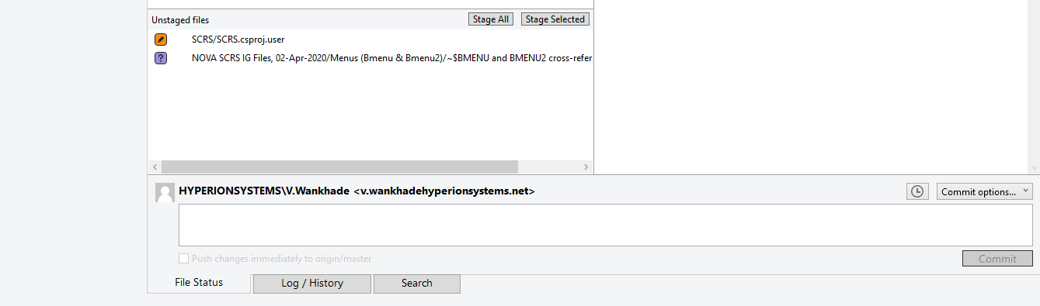

1. **File status showing that on which file you did the changes**

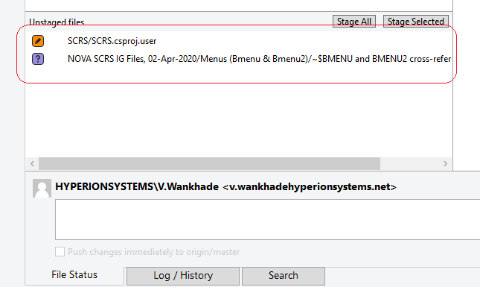

1. **After doing changes in a particular file you can stage single file or stage all**

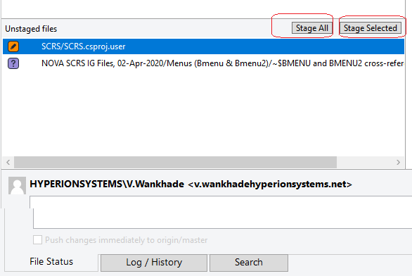

1. **After doing state selected file this file will come to stage window**

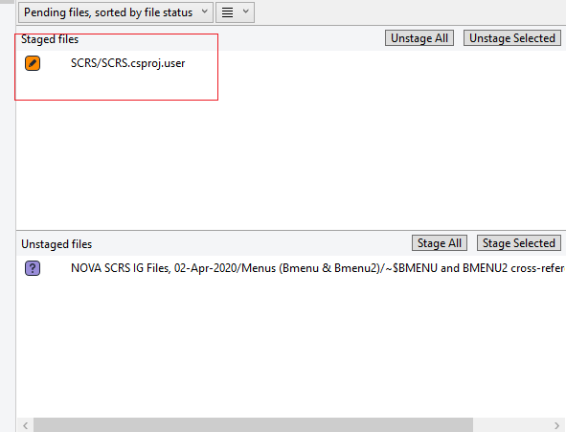

1. **After clicking on stage file you can see all the changes you are done with**

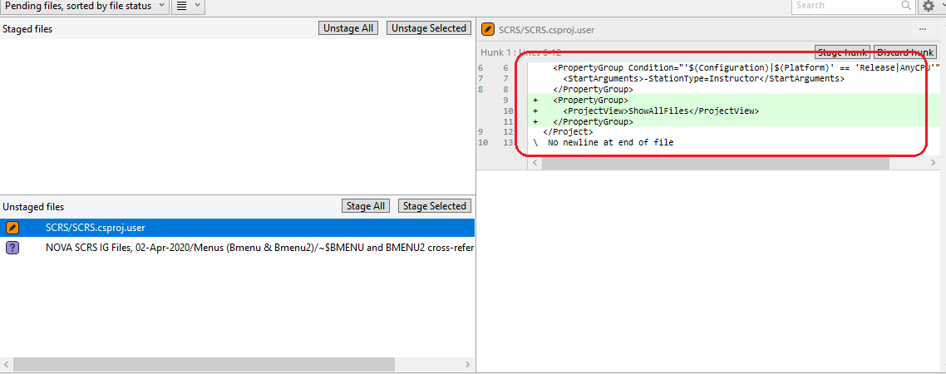

1. **Now you ready for commit. Write in comets in comment part and do commit**

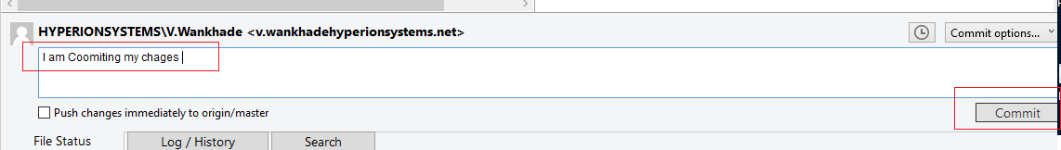

1. **After committing the changes you are ready to push your changes on master application**

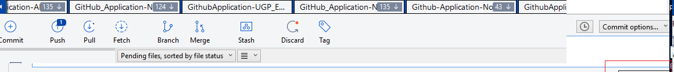

1. **Before push if your window is showing that there is something in pull action then first pull it and then push your changes**

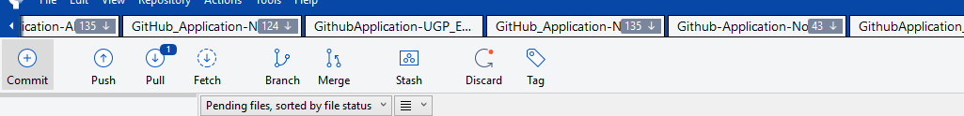

1. **After right click on stage file you can discard or remove it if you don’t want to commit**

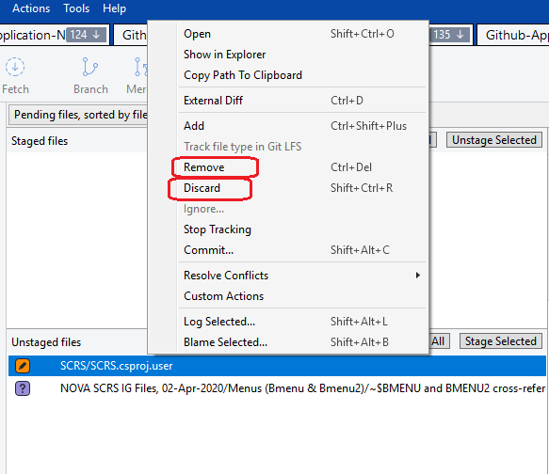

1. **In Log history tab you can see all the commit done by different engineers for your reference**

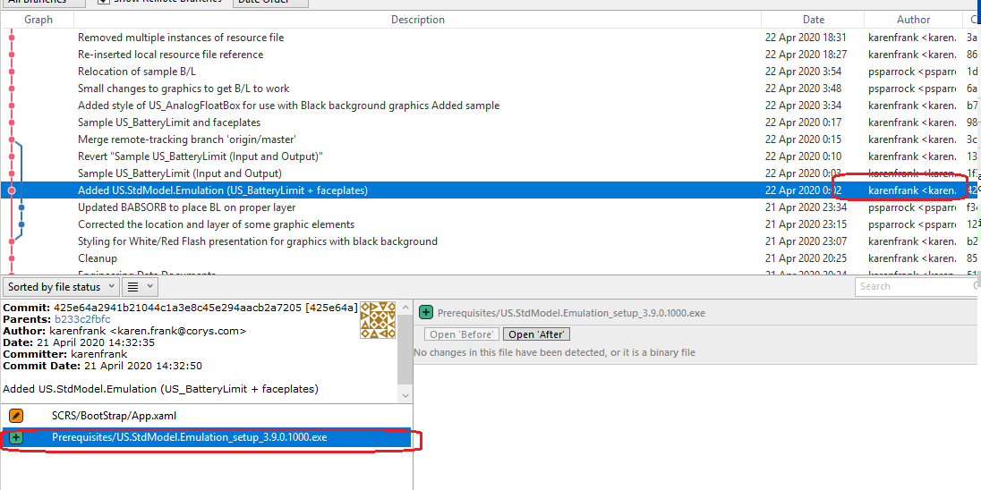

1. **You can track synchronization history and committing activity by tracking line**

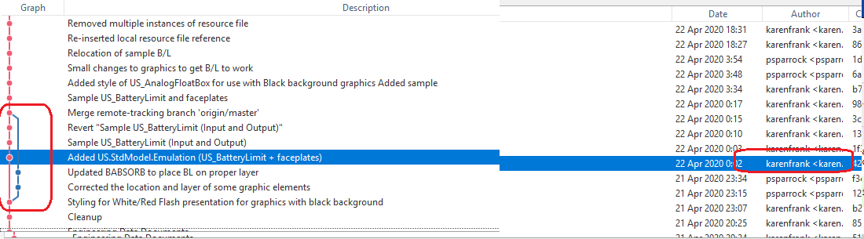

1. **You can search your commit in tab search option as well**

